## Occupant Feedback Thermostat Control

### Author

* Andrew Parker, NREL

### Description

Traditional thermostats have heating and cooling setpoints set based on typical operating hours and assumptions about occupant comfort. Occupant feedback thermostats actually enable occupants to modify these setpoints by reporting their feelings (hot, cold) to a central system, which uses this feedback to modify the heating and cooling operation. This measure may increase energy consumption if the current setpoints are currently too cold in winter or too hot in summer. It may also save less in buildings that already have aggressive nighttime setbacks.

### Modeler Description

Each zone is given a ZoneControl:Thermostat:ThermalComfort object with heating and cooling schedules set to a Predicted Mean Vote (PMV) of -0.5 during heating and +0.5 during cooling. This object will set the heating and cooling setpoints such that 90% of the occupants are comfortable. This control is applied 8am-6pm on weekdays. During the rest of the time, the building follows the current setpoints. It is not applied to zones without people.

### Use Case Types

Retrofit, New Construction

### Arguments

“run_measure” is a choice argument that determines whether or not the Measure is applied during a given run.

### Initial Condition Message

### Final Condition Message

The number of thermal zones the occupant feedback thermostat controls were applied to.

### Not Applicable Messages

Not applicable if no zones with people were found.

### Warning Messages

### Information Messages

Show the name of each zone that was modified.

### Error Messages

### Code Outline

* Find all thermal zones
* Skip any zones that don’t have people
* Add a thermal comfort thermostat and associated setpoints to each zone
* Enable thermal comfort calculations for each zone by specifying the “Fanger” comfort calculation algorithm in the people objects in the model.

### Tests

**This measure applies to:**

1. Large Office
2. Medium Office
3. Primary School
4. Secondary School
5. Large Hotel
6. Hospital
7. Small Office
8. Stand-Alone Retail
9. Strip Mall
10. Supermarket
11. Quick Service Restaurant
12. Full Service Restaurant
13. Small Hotel
14. Outpatient Healthcare
15. Warehouse
16. Midrise Apartment

### Test results

As you can see in the diagram below, during the winter, the occupant feedback is driving the new setpoint temperatures (blue) higher than the current heating setpoint (black), which increases energy consumption.

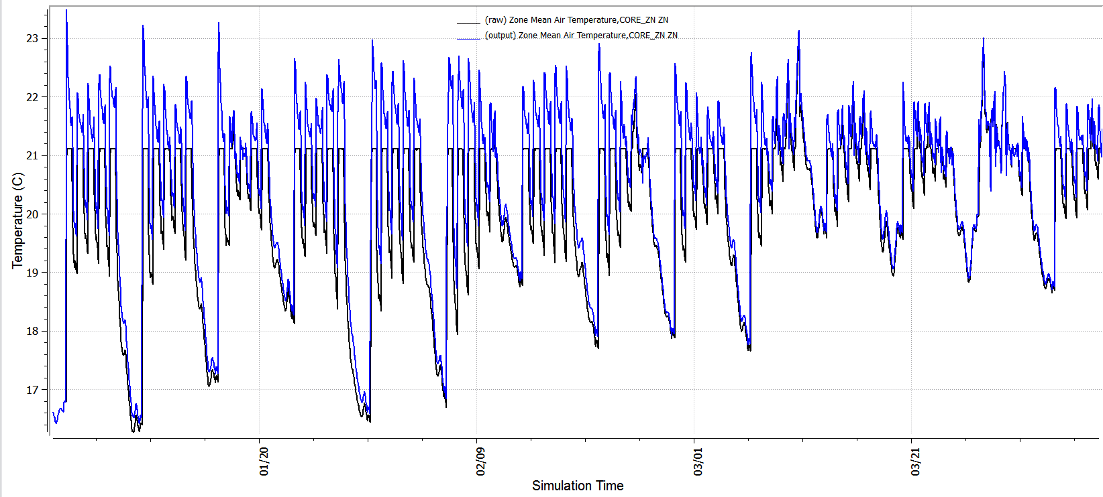

However, in the summer, the occupant feedback is typically making the new setpoint (blue) warmer than the original cooling setpoint (black), saving cooling energy.

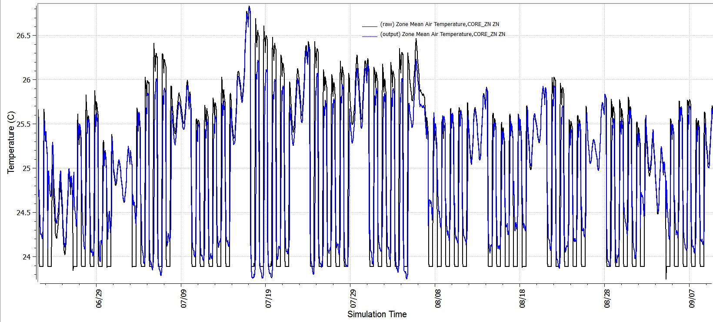

### References

1. <http://ceae.colorado.edu/~brandem/aren3050/docs/ThermalComfort.pdf>
2. <http://buildingrobotics.com/comfy/>